Real Time Operating Systems Design and Programming
Lab 5
OS Concurrency Lab
Producer and Consumer

Contents
1 Overview 2
2 The Environment 2
3 Lab Procedure 2

Overview
In this exercise, you will focus on the producer-consumer problem. You may want to use some primitives of RTX to solve the problem. There may be many possible solutions, and you are expected to evaluate their advantages and disadvantages.

The Environment
You will begin with a simple scenario of one producer and one consumer, where the producer will repeatedly produce an integer ranging from 0 to 19 at a random rate. The consumer will consume the integer created by the producer. Both threads share a single FILO buffer. Notice that the buffer provided could easily result in buffer overflow or underflow. Overflow is less of concern, and you can assume you have infinite space for buffer. The buffer size is predefined as ten and should be enough for the lab. Determining the optimized size of the buffer requires the knowledge of queuing networks and performance evaluation, which is not expected for this lab. The main point is to avoid the consumer consuming an empty buffer, which would cause underflow. Moreover, RTX scheduling applies a round-robin policy, which means it will pre-empt the producer or consumer periodically. This is a major source of data race conditions, and you are not allowed to change the round-robin settings in order to simulate the multicore environment.
Some of the random timing is generated by the `rand()` function. You may want to change the defined RANDOM_SEED value to see different timing results.
In this lab, you may use the watch window and the logic analyzer functions of μVision—see the lab procedure for more details. (This requires hardware debugger support. STLINK2, for example, supports these functions).

Lab Procedure
- Open the template project. Scan through the code.
- Notice there are few global variables: `producer_datum`, `consumer_datum` and `i`. The variable `i` keep tracks of the buffer order and points to the next available buffer space. The reason they are declared as global variables instead of local variables is that μVision cannot determine the value of local variables, as their scope is confined by the local function. This means that they are probably stored in a CPU register, which μVision is unable to access during run time.
- First of all, make sure only the producer is running by commenting out the line:
ThreadID2=os_tsk_create(Consumer,0);
Build and load the program, then enter debug mode. Add variables `i`, `producer_datum`, `consumer_datum` to the watch window, if the project template has not done this for you already. This allows you to observe the values of these variables at run time.
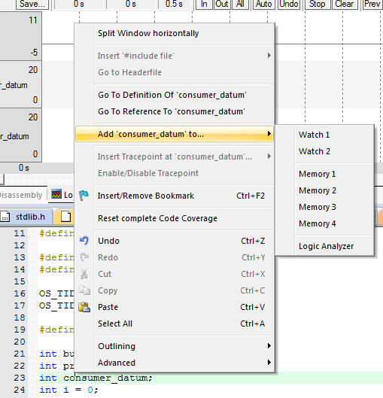
Figure 1 Right click on the variable and select Add to - Watch 1
Now run the program for a while, describe what you see, and try to explain the value of `i`.
The blue LED is flashing as the producer generates integers. Watch memory window 1, which should indicate that `producer_datum` is always changing while `consumer_datum` remains zero. The value of `i` will be incremented every time the producer produces a new integer. Buffer overflow will occur eventually if the program runs for long enough so that `i` becomes greater than 9. This may cause the program to be trapped in an error handler as the producer overwrites other memory blocks.
- Now do the opposite—just run the consumer and comment out the line:

ThreadID2=os_tsk_create(Producer,0);
Rebuild and load your program. Enter debug mode and run the program. Describe what you see and try to explain the value of `i`.
The green LED is flashing as the consumer consumes integers. Watch memory window 1, which should indicate that `consumer_datum` is always changing while `producer_datum` remains zero. The `i` will be decremented every time the consumer consumes a new integer. Buffer underflow will occur right at the beginning. This will do no harm to the program, as the consumer does not change the memory content.
- Now run both the producer and consumer. Repeat what you have done for Q4 and Q3. Describe what you see and try to explain the value of `i`. You are free to change the delay time in `append()`, `extract()`, `produce()`, and `consume()` to see how it affects the result.
The blue LED and green LED are flashing. The value of `i` will sometimes be incremented by the producer or be decremented by the consumer, depending on the random time delay. If `i` is above zero, then `consumer_datum` will copy the previous value of `producer_datum`. Otherwise, its value is unpredictable, as it is reading from another part of memory (buffer underflow). It is also possible for buffer overflow to occur (in the very long run, or if the delay time for extract and consume is longer) if `i` grows larger than 9. As the producer is writing to the memory, either buffer underflow or buffer overflow will contaminate memory space, which could eventually trigger the error handler.
- An alternative way to examine the problem is to use the logic analyzer, provided your board supports tracing—if not feel free to skip this part. The logic analyzer in μVision can sample the value of a specific memory location and plot the value so that everything can be represented visually and potentially in a more intuitive way. Do the following to configure the logic analyaer if the template project has not already done this for you.
Exit debug mode first if you are debugging. Select Target Options or press ALT-F7. In the Debug tab, click on the Settings button next to the debugger selector. Choose the Trace tab in the Cortex-M Target Driver Setup. Configure the Trace tab as follows, selecting a core clock suitable for your board (note that by default the core clock runs at 16MHz on the Discovery board):
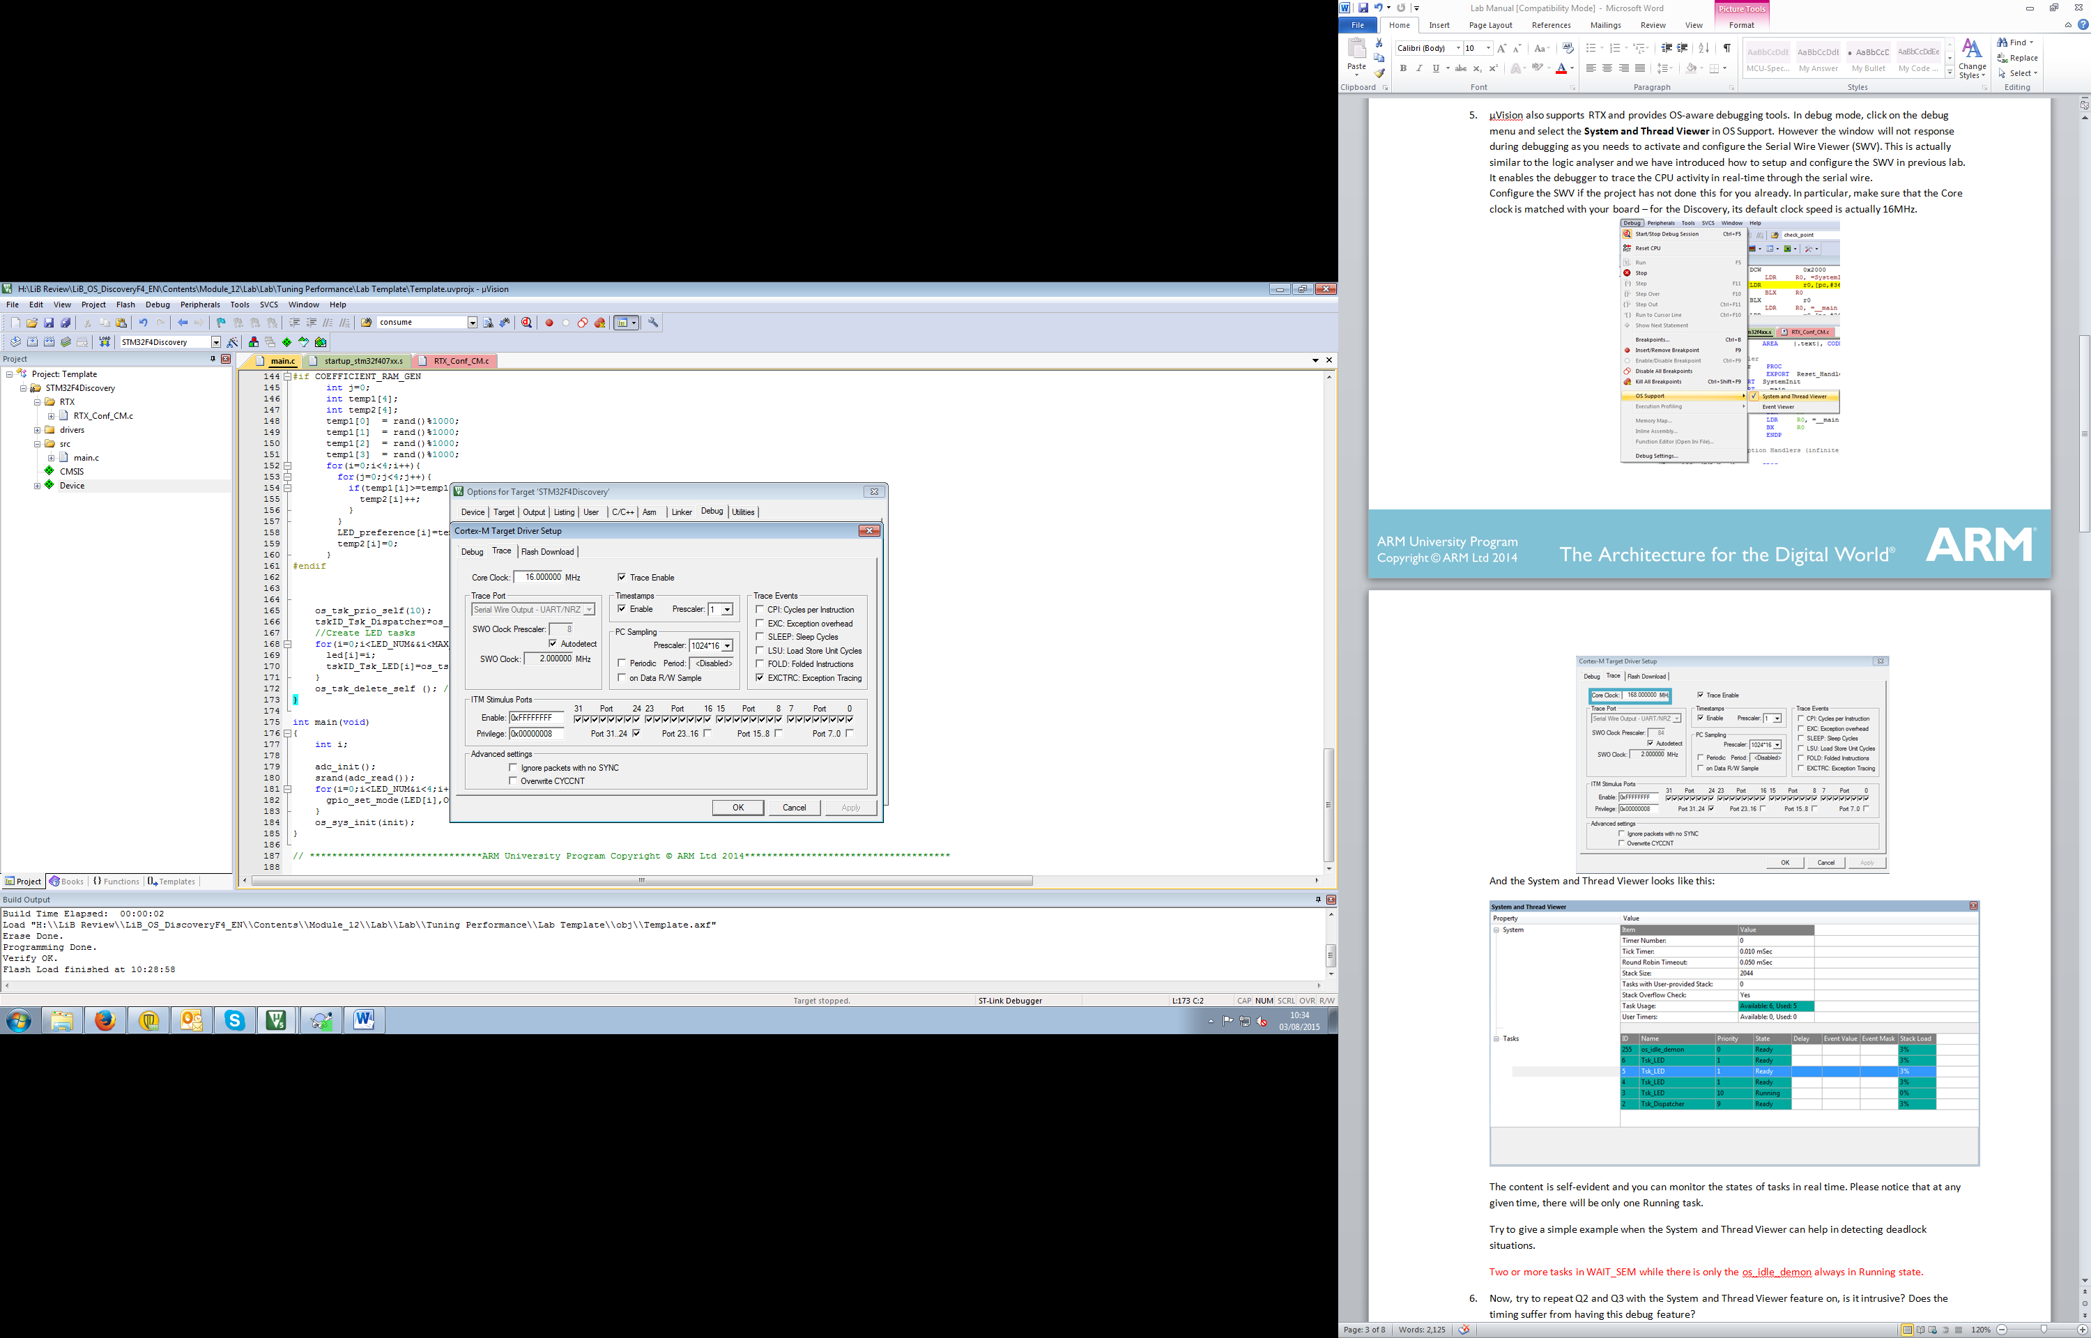
Figure 2 Set up SWO trace
This enables the debugger to trace CPU activity through serial wire output in real time.
After this, enter debug mode, and click the logic analyzer icon . You can add variables to the logic analyzer by right-clicking on the variable and selecting ‘Add to Logic Analyzer’. You can also set up everything directly in the Setup window of the logic analyzer. Additionally, you can adjust the display range of monitored variables—for example, set both `producer_datum` and `consumer_datum`’s Max and Min to 19 and 0 respectively.
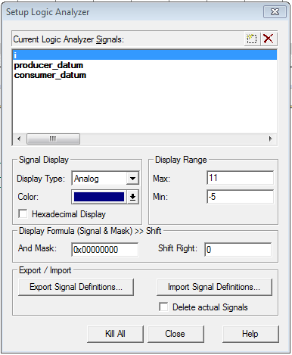
Figure 3 Setup Logic Analyzer
Once you have set up the logic analyzer, you can run your code and monitor the corresponding values of the monitored variables.
Run your code in debug mode, watch the logic analyzer, and check if it matches your result in Q5. A simple way to check if things are working well is to compare the trace of `producer_datum` and `consumer_datum`. Checking the value of `i` could lead to some conclusions.

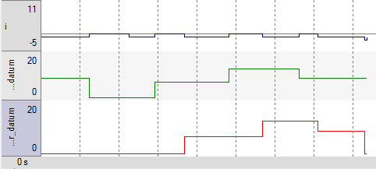
Figure 4 A Single Play
You are free to think of and implement your own solutions at this point to tackle the problem, ideally without unnecessarily delaying either the producer or consumer.

- It is suggested that access to the buffer should be made mutually exclusive. Does that work, and if so, how? Try to implement this idea and see if it solves the problem. Explain why or why not. You may refer to the slides on how to use the mutex primitive in RTX.
See the solution project for the code.
Implementing only the mutex has no positive effect at all. The consumer can still extract a datum from an empty buffer. Things could get worse if buffer underflow contaminates mutex-related information. For example, if your producer can no longer release the mutex, it is probably due to underflow contamination. This can be easily seen if the delay time for the consumer is significantly reduced.
- Using the mutex may not be very useful for this simple scenario. However, can you see how it would be useful in more complicated scenarios? Try to explain under what circumstances it would be a good idea.
It is generally needed because `append()` and `extract()` are not atomic. It is possible that one thread is pre-empted while it actually appending or extracting and waiting to modify `i`. A mutex can be useful when there are multiple writers. It is also necessary to make sure that underflow doesn't happen so that mutex-related information will not be contaminated.
- It is suggested that by strictly controlling the sequence of the program flow, this problem can be solved. Try to modify the Producer and the Consumer threads to make sure there is at least one produced datum in the buffer before the consumer consumes. Run your code and see if it works, and try to explain the result. You may refer to the slides on how to use the mutex primitive in RTX.
See the solution project for the code.
A semaphore can be used to implement this signaling mechanism. It does solve the buffer underflow problem if `append()` and `extract()` are atomic. However, when they are not atomic, these could still lead to unpredictable memory corruption or an incorrect reading sequence of data. This is not easy to notice in the provided template, but if you significantly prolong the delay time of `extract()`, it will become obvious.
- The following producer thread and consumer thread code can successfully tackle the problem:
init(){
sem_init(sem1,1);
sem_init(sem2,0);
…
}
Producer(){
Datum=produce();
sem_wait(sem1);
append(datum);
sem_send(sem1);
sem_send(sem2);
}
Consumer(){
sem_wait(sem2);
sem_wait(sem1);
datum=extract();
sem_send(sem1);
consume(datum);
}
Implement this and explain why it addresses the problem by explicitly analyzing roles of sem1 and sem2. You should pay particular attention to their initialization.
See the solution project for the code.
This producer-consumer problem actually includes the reader-writer problem because the buffer is shared. Therefore, a mutex is definitely needed. This is why sem1 is implemented as a binary semaphore, which is effectively a mutex that ensures access to the buffer is not interrupted. Sem2 keeps track of the number of data items in the buffer and prevents the consumer from extracting from an empty buffer.
- What if the two sem_send()s in the producer thread are swapped? Does that matter? Explain why.
See the solution project for the code.
It is not necessary to implement the code to see the result. Pre-emption in any other part of the code does not affect the result. It only matters if pre-emption occurs between these two `sem_send()` lines. In that case, the counter for the data items will be incremented first, then pre-empted by the consumer. The consumer will not be allowed to enter the buffer even if it has the ticket for sem1 because sem2 is blocked by the producer, so it does not matter. However, it is better programming practice to release the mutex as soon as the code exits the critical section.
- What if the two `sem_wait()` calls in the consumer thread are swapped? Does that matter? Explain why.
See the solution project for the code.
It is not necessary to implement the code to see the result. Assume pre-emption occurs between the two swapped lines. Deadlock could occur because the consumer is holding access to the buffer while waiting for the new data. If there is no data, then the producer will not be able to create any either, as it cannot append new data to the buffer unless consumer releases sem1.
- It is suggested that by combining the methods mentioned in Q7 and Q9, you can find another solution, which is effectively the same as the method in Q10. Try to implement this and run your code. Are they the same? If yes, explain why. If not, what are the differences and which is better?
See the solution project for the code.
This implies a signalling scheme with a mutex is required. Actually, sem1 in Q10 plays the role of the mutex, so in terms of solving the problem, they are effectively the same. The difference between using a mutex and a semaphore to access the buffer is that a thread can increment the semaphore even if it does not hold a ticket for it, whereas a mutex can only be released by the thread currently accessing it. Therefore, it may be a better idea to use mutex so that other threads cannot corrupt your access to the buffer. However, given that your code is correct and organized, they are effectively the same.
- This is a bonus question. It is possible to implement a general semaphore using an integer variable (assume it is private and other functions cannot modify it) and two binary semaphores. How? You may draw inspiration from Q10. Assume you have the following global variables:
OS_SEM semIDA;
OS_SEM semIDB;
int tickets;
Produce the implementation of the following functions based on RTX semaphore primitive (assume it is binary and set all timeouts to infinite):
void general_init_sem(int initial_value);
void general_wait_sem(void);
void general_send_sem(void);

Notice that the RTX semaphore is actually general. If you like, test your answer. Running the template project may not reflect the real situation.
See the solution project for the code.

